Traveler Name

Visit to

City, State/Country
City, State/Country
City, State/Country

27 May – 15 July 2022

US Embassy, UK
33 Nine Elms Lane
London SW11 7US
+44 0 20 7499 9000

US Embassy, Bulgaria
16, Kozyak Street
Sofia 1408, Bulgaria
+359 2 937 5100

Monday, 27 June 2022
Washington DC

Dress: Travel Casual
Washington DC: 78/59

2200 Depart Dulles enroute Frankfurt
- United 932
- Confirmation: IVQD2G
- FT: 8:20 min (ADV clock 6 hours)

Tuesday, 28 June 2022
Sofia, Bulgaria

Dress: Travel Casual
Sofia: 82/59
1210 Arrive Frankfurt

1630 IP3 Weekly Update w/BDD
- Via Google Meet

1915 Depart Frankfurt enroute Sofia
- United 9270 (Lufthansa)
- Confirmation: IVQD2G
- FT: 2:10 min

2225 Arrive Sofia

Depart enroute Sense Hotel
- Via Uber/Taxi
- DT: 0:10 mins

Arrive Sense Hotel
- 16 Tsar Osvoboditel Boulevard Sofia 1000 Bulgaria
- Front Desk: +359 2 446 2500
- Confirmation: 84191689

Wednesday, 29 June 2022
Sofia, Bulgaria

Dress: Business
Sofia: 84/60

At Leisure Depart enroute Elieff Center for Education and Culture
- Uber/Taxi
- DT: 0:15 min

1330 Arrive Elieff Center, 1700 Studentski Kompleks

Atlantic Club Energy Dissected 2.0

1400 Welcome Remarks
- Dr Solomon Passy, President Atlantic Club
- David Evans, President American University in Bulgaria

1410 Keynote Address
- HE Hero Mustafa, Amb to US in Bulgaria
- RDML Mike Hewitt, CEO IP3
- Alexander Nikolov, MoE of Bulgaria

1430 Roadmaps to Action: What is required to generate energy security
at a national, European, and international level?
- Moderator: Amb Elena Poptodorova, VP Atlantic Club
- Panelists: Amb Richard Morningstar, Vladimir Milov, Radoslav Ribarski, Dr Mikhail Krutikhin, Vitor Nasr

1550 Aligning the Energy Policies – Transfer of Technology and Business
Models from South to North
- Moderator: Andrey Bachvarov, CEO Bica Services and Anthil
- Panelists: Alexanra, Sdoukou, Lukas Mandl, Dirk Bushle, Edward Friedman, Kiril Boshov

1700 Renewables as Investment in Volatile Energy Markets
- Moderator: Kaloyan Staykov, Chief Economist EMI
- Panelists: Amb Ilyan Vasilev, Milko Kovachev, Boyko Nitsov, Miglena Stoilova

1815 Adjourn

Thursday, 30 June 2022
Sofia, Bulgaria

Dress: Business
Sofia: 87/61 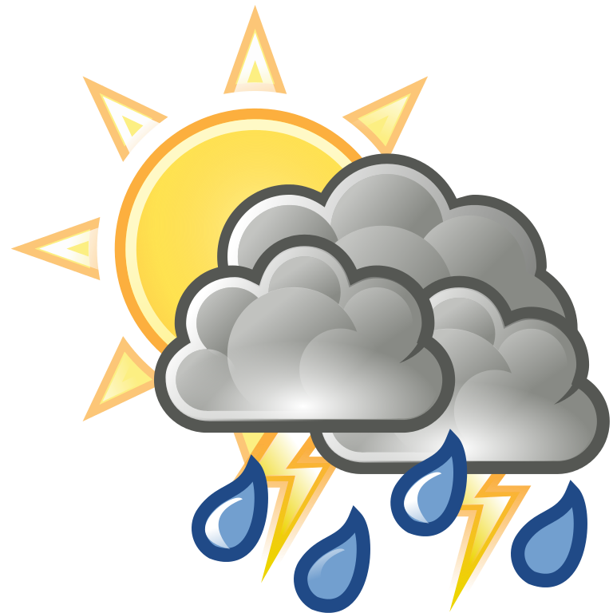
Meetings TBD

1600-1700 ANP Weekly Africa Update
- Via Google Meets

Friday, 1 July 2022
Sofia, Bulgaria

Dress: Business
Sofia: 87/63

Meetings TBD

Saturday, 2 July 2022
Sofia Bulgaria, Mykonos Greece

Dress: Travel Casual
Sofia: 87/62
Mykonos: 79/72

At Leisure Depart enroute Sofia Airport
- Via Uber/Taxi
- DT: 0:10 mins

0600-0655 Depart Sofia enroute Munich
- Lufthansa 1707
- Confirmation: SFOIAK
- FT: 2:30 min (RET clock 1 hour)

0810-1140 Depart Munich enroute Mykonos
- Lufthansa 2532
- Confirmation: SFOIAK
- FT: 2:20 min (ADV clock 1 hour)

Depart enroute Amb Mosbacher Residence
- Via Mosbacher Driver

Sunday, 3 July 2022
Mykonos Greece

Dress: Casual
Mykonos: 79/72
Meetings TBD

Monday, 4 July 2022
Mykonos Greece

Dress: Casual
Mykonos: 79/72
Meetings TBD

2000 IP3 Weekly Management Team Update

2200 IP3 SitRep

Tuesday, 5 July 2022
Mykonos Greece, London England

Dress: Casual
Mykonos: 79/72
London: 76/54 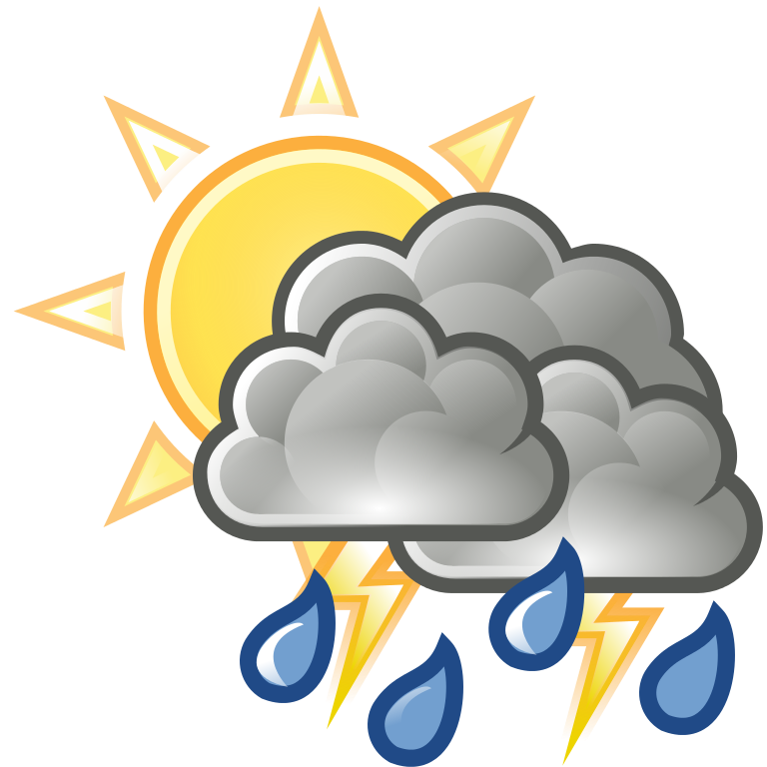
At Leisure Depart enroute Mykonos Airport
- Via Mosbacher Driver

1430-1630 Depart Mykonos enroute London
- British Air 651
- Confirmation: PJL9YW
- FT: 4:00 min (RET clock 2 hour)

Depart enroute Residence Inn London Kensington
- Via Uber/Taxi
- DT: 0:45 mins
Arrive Residence Inn London Kensington
- 181-183 Warwick Road London
- Front Desk: +44 20 3146 7980
- Confirmation: 85752493

1530 IP3 Weekly Update w/BDD

Wednesday, 6 July 2022
London England

Dress: Casual
London: 77/57
Meetings TBD

Thursday, 7 July 2022
London England

Dress: Casual
London: 77/57
Meetings TBD

1500 IP3 Weekly Africa Update

Friday, 8 July 2022
London England

Dress: Casual
London: 77/57
Meetings TBD

1500 Weekly Update w/Rich Deakin

